We are going to create a retail business sales report with graph and charts. However, we need to clean our data before we create our workflow for process automation.



We have cleaned up our data by removing duplicates, filling in null rounding up or numbers, calculating total revenue, profit margin and figured out the item is profitable or not.

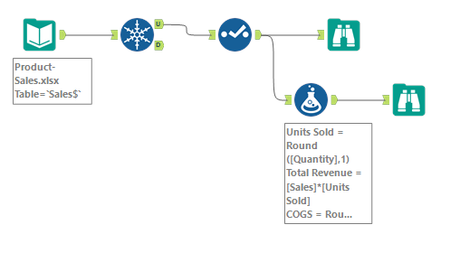

In his section we will create charting components.

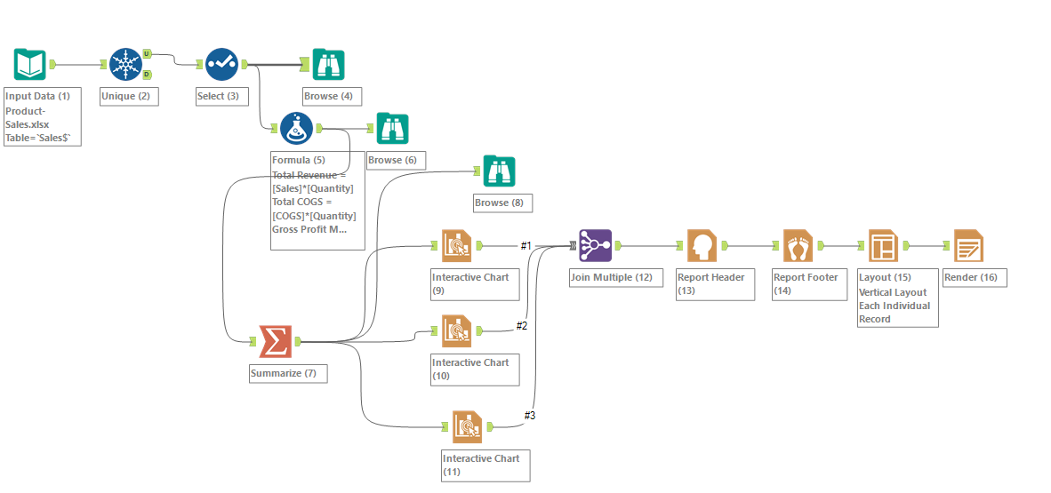

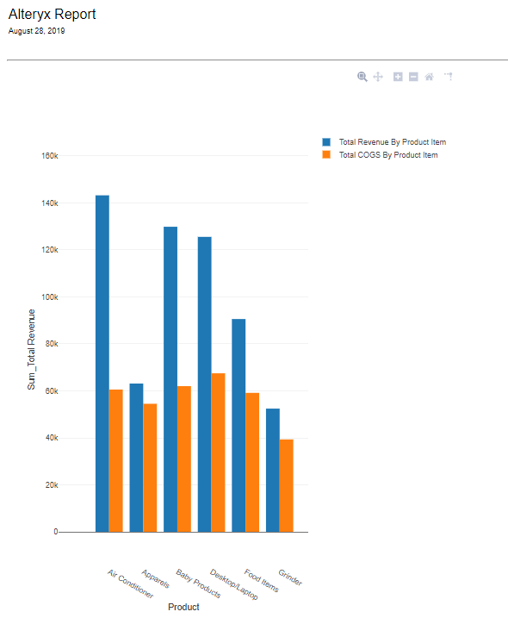

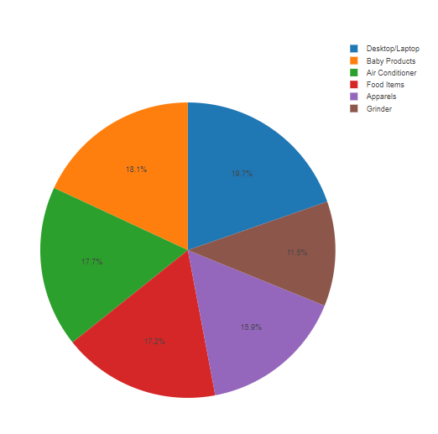

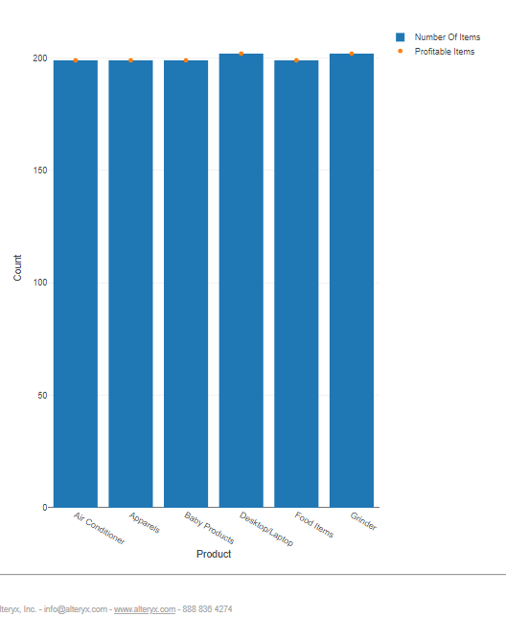

Now we will create a pivot table as the Summarize tool does not have this functionality.

In addition to our existing Summarize tool, we will add another Summarize tool in parallel and this time we are not going to group by product item.

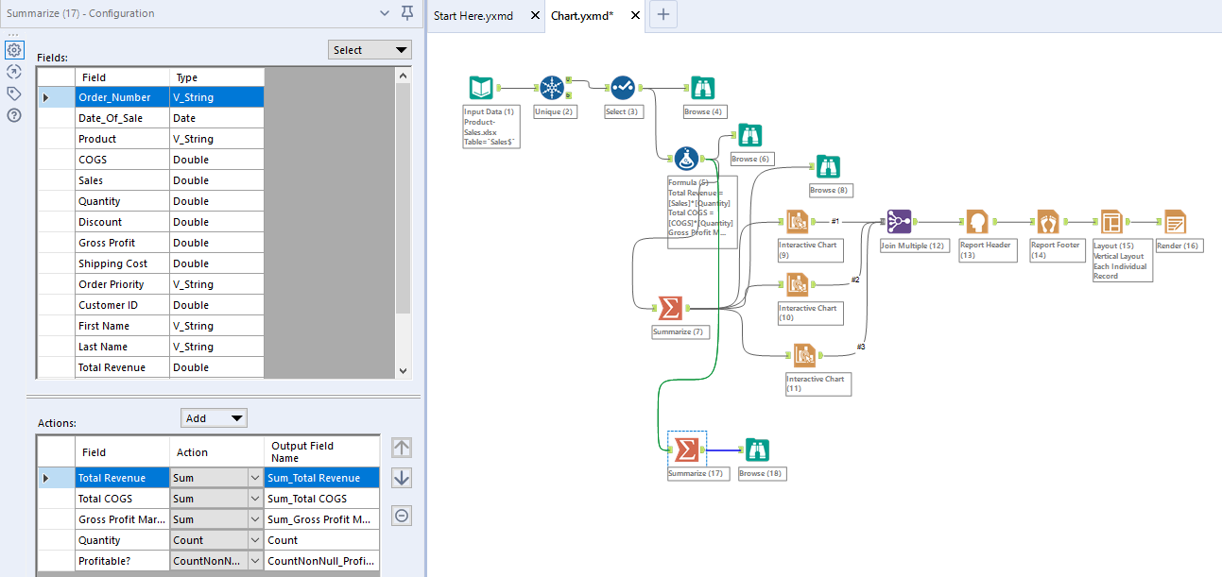

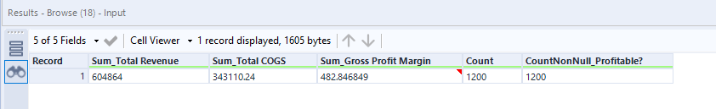

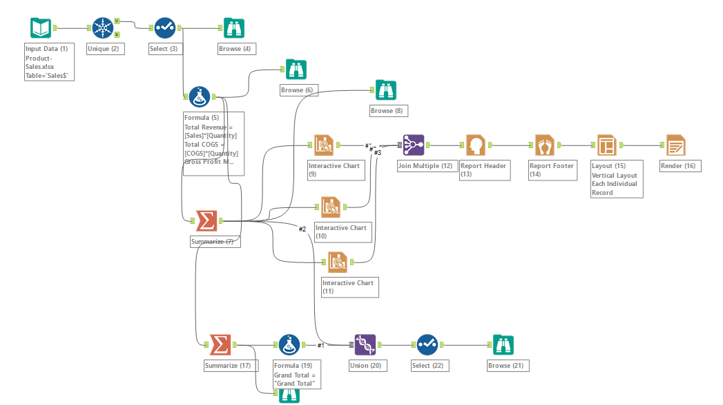

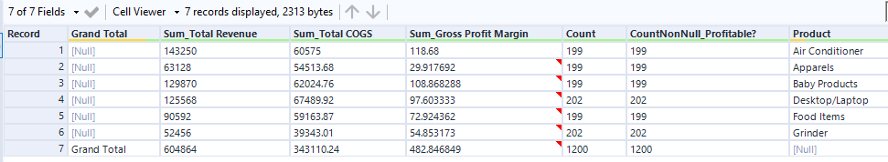

In the below workflow we are going to identify the best buy and sell prices for crypto-currencies combining information together to determine if there are any good arbitrage opportunities.

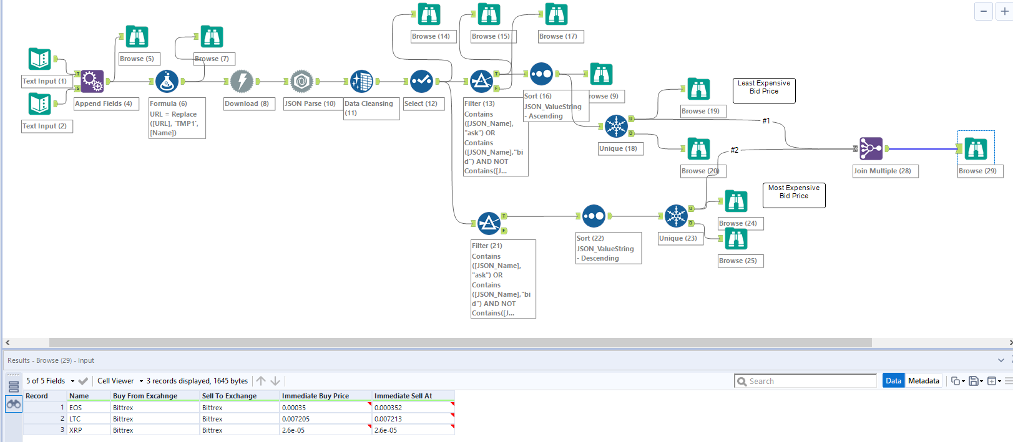

Special Analytics

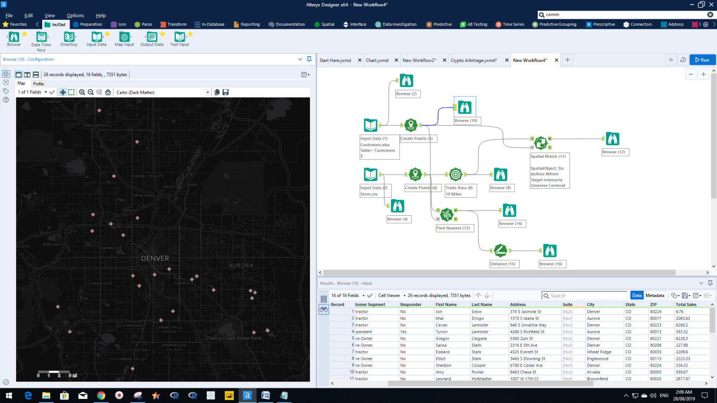

Our target

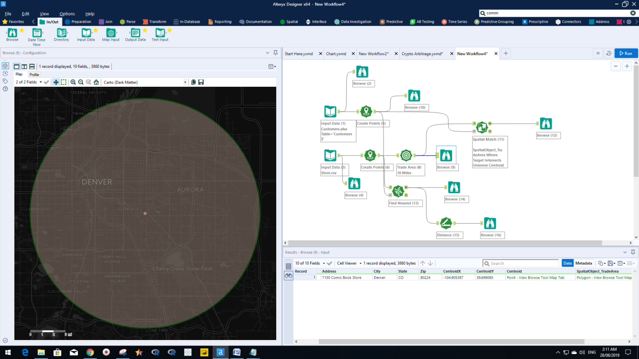

The target customer intersects the universal customers

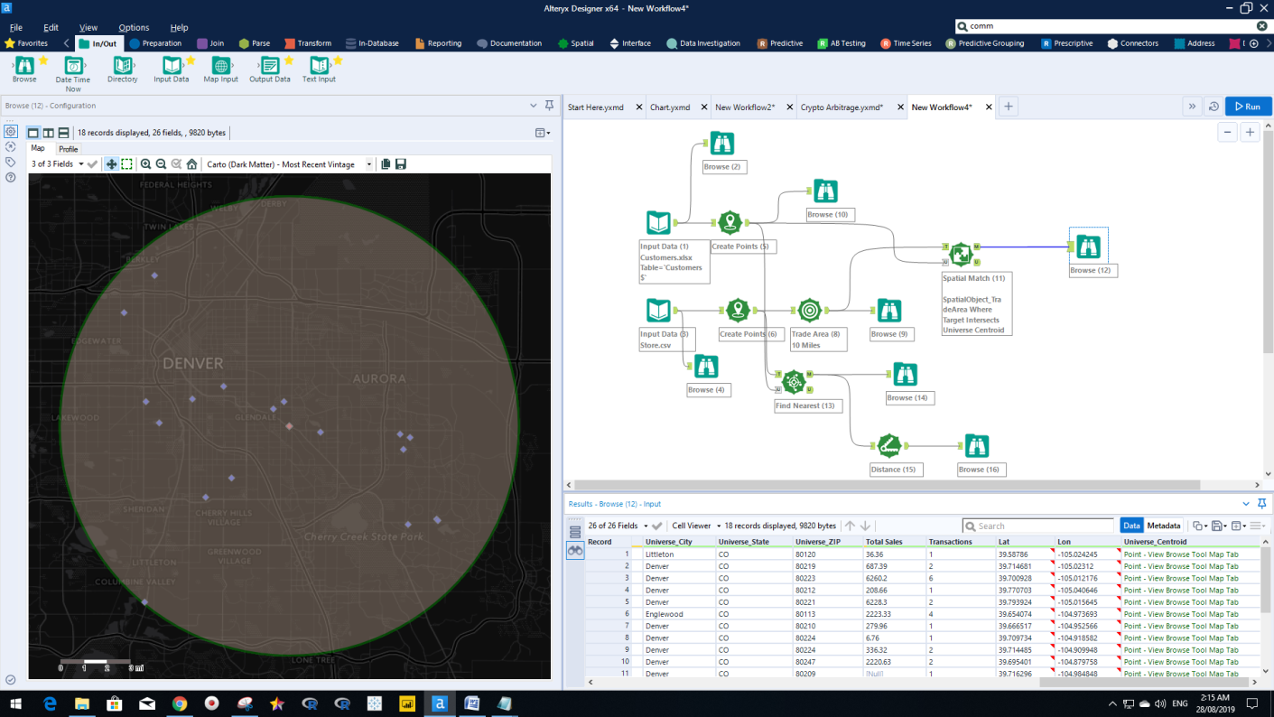

Now we want to see our five nearest customers of the target customer with the distance and direction.

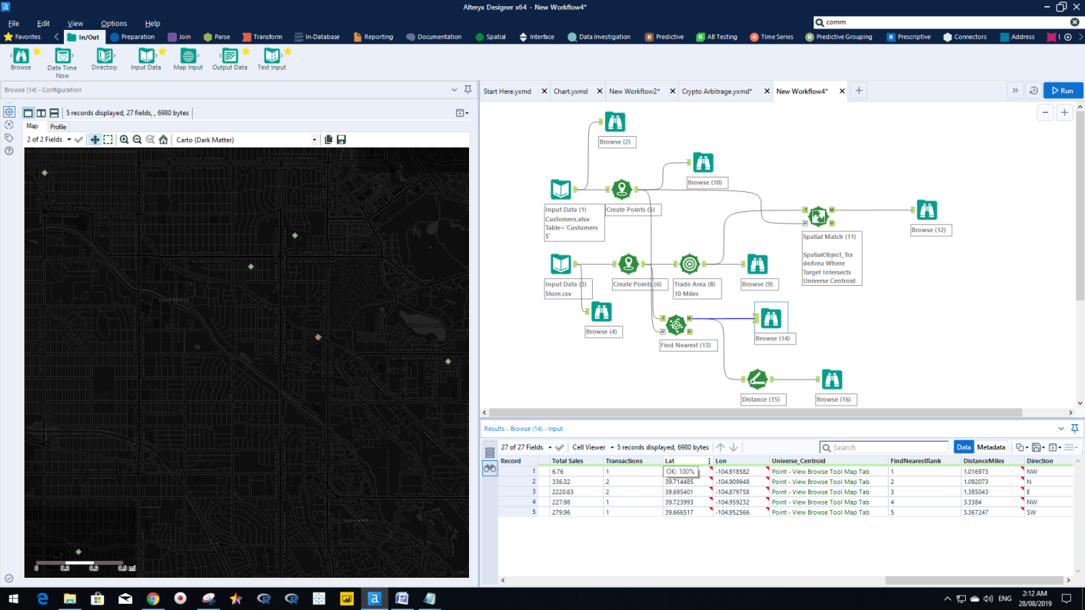

Match

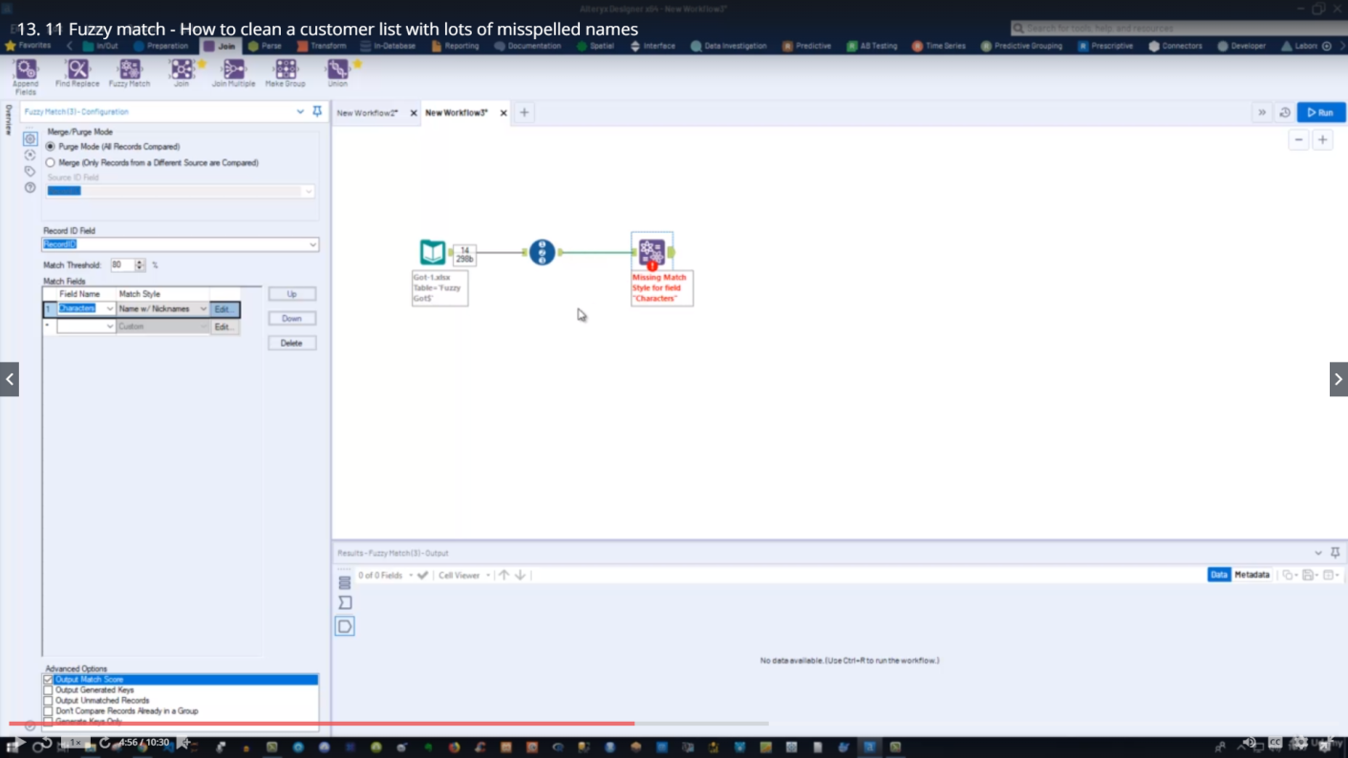

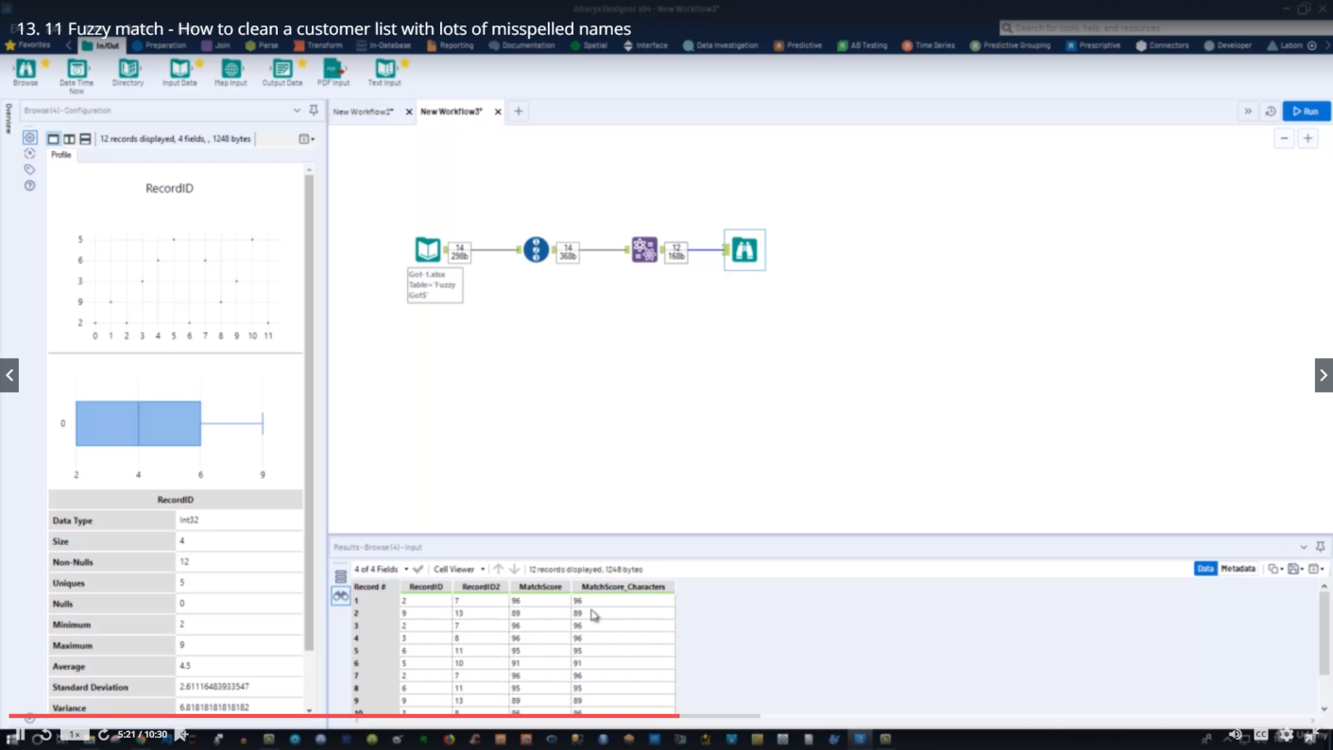

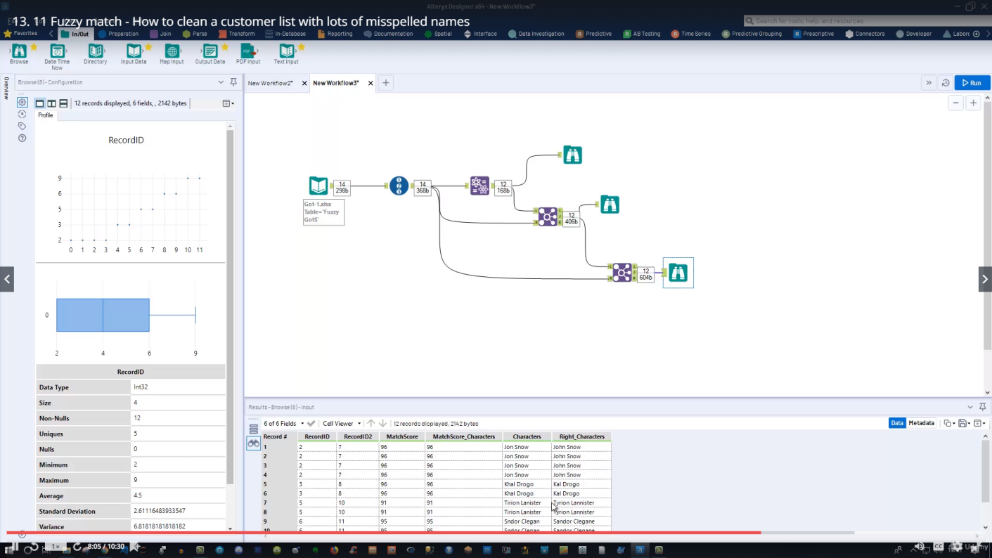

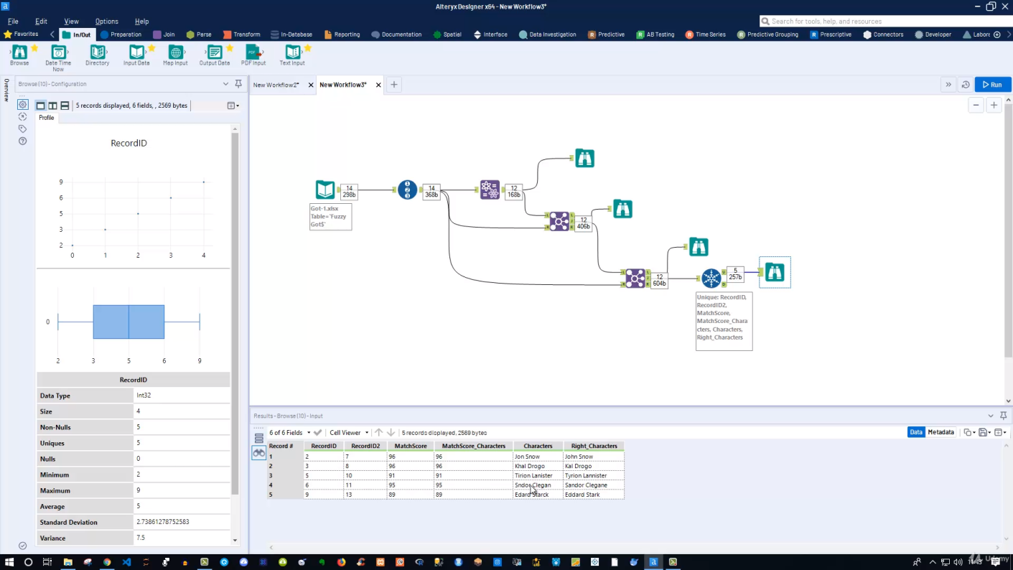

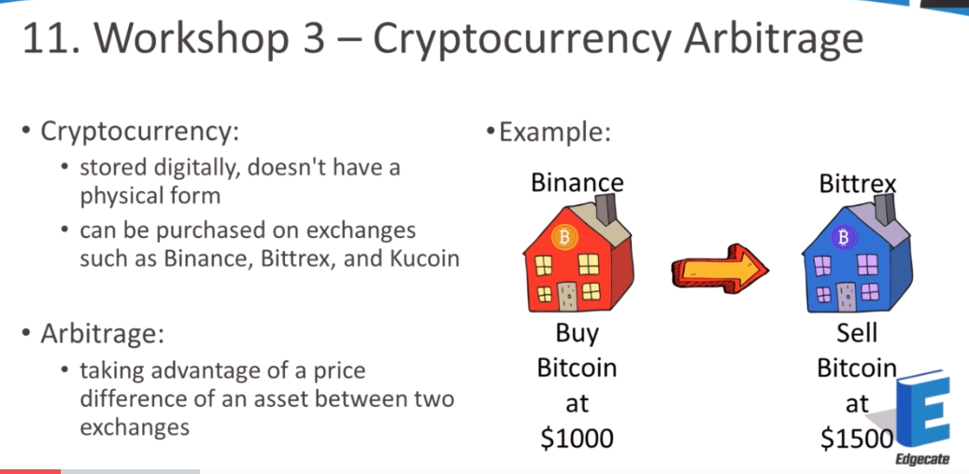

Welcome to the third and most advanced workshop where we will be creating a cryptocurrency arbitrage

robot if you already understand cryptocurrency and arbitrage then off the bat this is going to make

a lot of sense if not let me give a quick introduction.

Crypto currency at a high level is much like a regular fiat currency like a UTI USD and yen but it's

only stored digitally and doesn't have a physical form crypto currency can be bought and sold on exchanges

similar to how shares are traded on the share market.

Some popular cryptocurrency exchanges are by Nance Beatrix and coo coin.

The price of most crypto currencies are usually shown as relative to the price of one bitcoin or in

USD.

For example you may see other crypto currencies like ripple worth point 0 0 0 9 8 1 and light coin as

point 0 0 8 something something and Bitcoin cache with a price of point 0 0 4 3 etc..

These prices are relative to bitcoin.

So for example if Bitcoin Cash is worth approximately 4 percent of one bitcoin and if we take one divided

by 4 percent we can say that the price of one bitcoin is roughly equivalent to 23 24 Bitcoin Cash arbitrage

is taking advantage of a price difference of an asset between two exchanges.

For example you might see Bitcoin on buy an ounce for 1000 dollars and bitcoin on Beatrix for fifteen

hundred dollars.

Therefore the arbitrage opportunity would be buying bitcoin on finance and then selling it on Beatrix

for a profit of five hundred dollars.

The workflow we'll be making today will identify arbitrage opportunities but won't do the trades for

you so because we're dealing with the potential sensitive topic of money before moving on.

I'd like to mention that this video is purely for learning purposes only specifically to demonstrate

how to utilize the download and Jason powers tools and how to use the standard macro.

We discuss these in Chapter 6 and 7 but haven't yet put it into practice.

This video isn't financial advice and it's not made with the intention for you to make money and I highly

discourage you from using it the work for for that intent if anything you'll most likely not make any

money at all from this at the time of making this video.

I don't own bitcoin but I do own several other crypto currencies.

However I don't own any of the example crypto currencies will be talking about in the workflow.

If you decide to use this workflow for trading.

I'm not responsible for any of your actions losses or gains.

I'm going to say this one last time.

Please don't use this workflow to trade crypto currency.

This is purely for learning only.

So with that out of the way.

For starters you'll notice our source files contain a version 1 and version 2.

And that's because for the first part or version one of this workshop we're going to build our workflow

and have a working product.

The second part will be converting this to our macro.

Let's have a look at what this workflow will look like.

I know this looks like a lot to take in so I've broken the workshop up into several components so they're

easier to digest.

The first component selecting your exchanges and currencies will start with two text input files.

The first is the exchange you are ls and the other one is for listing the coins we want to research.

We're going to combine these two inputs together and replace parts of the exchange U.R.L. with our coin

name or download the prices which will be returned to us in a table and then we'll identify the best

price for each coin.

Finally will determine if there are any worthy arbitrage opportunities.

The end result will look something like this.

Here we have the name of our coins.

The cheapest exchange to buy them from the price and the exchange to sell them out with their associated

sell price.

In this example like coin Tron and ripple don't have any worthy arbitrage opportunities so there's no

action to pursue.

The second part of this workshop will be taking the workflow and converting it to a macro which will

look something like this

this blue dot is a macro input tool that references the actual macro which is more or less how version

1 workflow

his our macro or before moving on.

If you're already familiar with what API Jason bid and ask prices are and how arbitrage works you can

probably skip the next video or but if this is new to you I highly recommend watching the next video

to provide context and background about what's happening.

So before we select our exchanges and currencies I want to explain some of the jargon I'll be using

as it can get pretty confusing.

In order to download coin information we're going to be using an API call which stands for Application

Programming Interface which means a particular Web site or company is providing us access to specific

features or functions within their application.

Instead of giving us access to the whole application itself in this example an exchange is providing

us their price information without giving us access to that exchange as a whole to bring this to life.

Let's take the Nance API U.R.L. and look up the price of bitcoin against the US dollar.

The Bonanno exchange has provided us the Bid and Ask price.

With all these curly braces and quotes which is actually a format called Jason or JavaScript object

notation which is another way of structuring data think of Jason as an alternative to excel.

What we want out of this Jason is the bid and ask price with bid as the name suggests.

And what you would normally do at an auction you're submitting a bid to buy bitcoin at three thousand

seven hundred and eighty three dollars with ask if you already hold Bitcoin or something else you want

to sell.

You would normally submit an asking price for it and looking at the ask price here people have submitted

orders to sell bitcoin three thousand seven hundred and eighty three dollars so the price difference

between bid and ask is one dollar.

If you can't remember which one is buy or sell.

I always remember it as bid and by birth start with B.

Therefore ask is sell the bid price will always be lower than the sell price therefore if I wanted to

buy bitcoin I can buy it immediately at the asking price which will be more expensive.

All I can submit a bid.

Play the waiting game and hope someone sells it to me for the price that I want.

Depending on the bid price you've put you might only have to wait one minute or one day or even longer

to get your order fulfilled.

Sometimes your bid will never get fulfilled because you may have put an unrealistic bid of one dollar

instead of something closer to the current prices.

To put it into perspective let's go through the scenario of buying Bitcoin at the ask and bid price

and then selling bitcoin at the ask and bid price so using the example at the bottom.

If we were to buy bitcoin we can buy it at the bid price of three thousand and the ask price of three

thousand five hundred now.

Buying Bitcoin at the asking price is more expensive than the bid because that's the price the seller

has set it at.

However I'll be able to purchase it immediately.

Buying Bitcoin at the bid price is cheaper than the asking price but there may be a delay to purchasing

it as it requires someone who already earns bitcoin to sell it to you at that lower price.

Now let's go through the scenario of selling bitcoin.

If I were to sell bitcoin at the asking price I get a better ar y but I may have a delay in my sell

as it requires someone to buy it at that more expensive price.

Selling bitcoin at the bid price has worse are why but I'll be able to sell it immediately.

So because arbitrage requires quick reactions and for orders to be fulfilled immediately we need to

identify the exchange with the cheapest ask so it can be bought immediately and then identify another

exchange with the most expensive bid so it can be sold immediately.

Putting all that into context now lets go make our workflow.

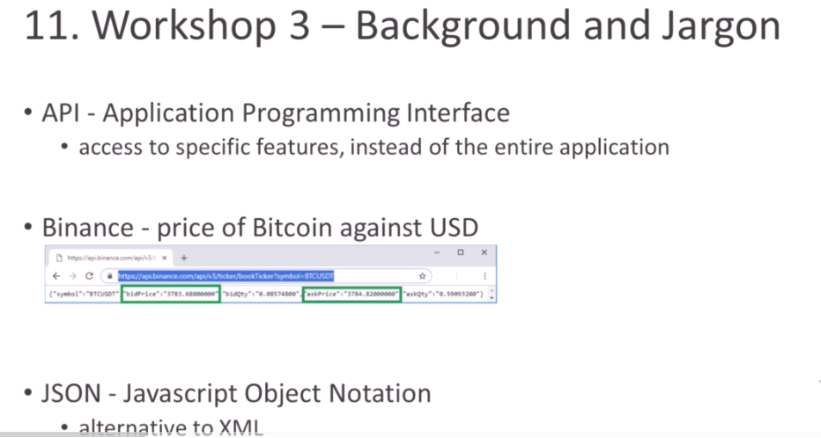

In the previous video we identified the best buy and sell prices and now we're going to combine all

that information together to determine if there are any good arbitrage opportunities.

Let's start by combining our data by dragging in a join mode support tool from the join tab

will join the two unique anchors into the join multiple and we're joined by a record position.

Since our sell and buy prices are filtered and sorted in the same way so our coins will always be in

the same position.

Therefore joined by record position can be used in this instance let's update the field names in the

configuration pane.

So for input 1 which contains our immediate buy price information we'll rename input one exchange to

buy from or buy from this exchange and then for Jason value string.

This will be our immediate buyout or immediate buy price input to exchange or call this sell to or sell

to this exchange and then for adjacent value string here.

This would be immediate sell at since we don't need these fields anymore.

Jason name and input to name and input to and Jason name and input.

1 we can unstick those.

And then lastly we will update our data types for Jason value streams to double as they are going to

be numbers and not text.

And then we'll add a browse tool to the end of our workflow.

And if we run our workflow we can see that our buy and sell data have now been combined in the same

row.

Now we're going to finish this off by writing a formula to determine the price difference between a

buy and sell as a percentage and also a text field to advise on the best course of action.

So let's drag in a formula tool from the preparation tab

and we'll create a new output column called return.

And this is going to be our immediate sell at minus how immediate buyout we're hoping to see a positive

number from this calculation now that we have the price difference.

We want to see it as a percentage so we'll add another output column and call this one return percentage

will add a round function

and fill in the parameters here.

So X will be our return to voided by our immediate buyout multiplied by one hundred

and we want to rounded off to a multiplier of one which will give us a whole number.

This is giving us an error here.

Because we've got the string data types so we'll change this to double.

Change this to double

and we'll add a browse tool to our workflow and run it

and there we have our return details.

So there was a problem with the recording here.

But what I want you to do is create a new output column with the formula tool and name it.

Action will then insert and if function into it by clicking on the effects icon and locating the function.

So our C condition is going to be returned.

Percentage is more than or equal to 9.

And if that's true then we want a text to output identified otherwise or return no arb.

Let's run our workflow and see if any arbitrage opportunities have been identified

so it looks like there were no arbitrage opportunities as all exchanges have their coins.

Similarly priced there you have it you now have a working product that identifies price discrepancies

between cryptocurrency exchanges I know the results may look a little underwhelming but you can research

other coins to find arbitrage opportunities.

Congratulations on making it this far.

I know this workshop contained a lot of new concepts and jargon which can be pretty confronting but

I hope you learnt a lot from it and can apply it to your work.

So as I highlighted at the start of this video it's most likely that you won't make any money from this.

And at the time of recording this video the market isn't doing very well and this is purely for learning

purposes only in the next video.

We're going to convert our workflow into a macro and dynamically control the arbitrage percentage instead

of a static 9 percent.

Special Analytics:

And this time we're going to dive into a spatial analytics in old tricks.

So I'm just want to briefly cover what I consider at least the most basic functions you often use on

which are pretty interesting in case you do spatial analytics and old tricks.

Now let's get into that.

Let's hear the special lyrics.

TAPS is here.

In case you can't see it then they need to activated.

You simply click on this little plus I can hear and then you select spatial here.

OK.

Because it's by default integrate and alter ego.

But maybe it's currently not selected so you concede OK as soon as you've done that then should be available

here.

And now let's take a look at our data.

All right.

So in my folder and in your resource section you can download here the custom Excel items X as well

as the stasis fee file.

And I want to put this in all tricks so I can go to my favorites tool and go to my input data here to

track it and then I'm connecting to file in my case I've selected it so I can also take it from here.

So say customers x is x selecting my sheet which is the customer's sheet that's fine.

OK.

And here we go.

OK.

And also also got a preview here of what my data looks like.

But of course I can also take a look at it if I run it in the browser tool and click on run and press

control are.

And take a look.

You can see I got a customer I.D. store no customer segment respond to and so on.

And what's interesting here of course the first and last name John Snow called Logo and so on so should

be familiar.

Even though there are also other names like for instance Bob Kelso or Christopher Turk Barry Cox John

Dorian you might be familiar with them as well.

All right.

So let's get into that.

So the next thing is we go in here and we also have the stasis we get.

That's what it holds.

So I can also take my input data tool here again drag and drop it and select it from here and say I'd

like to see my stasis here as well.

OK.

All right.

And also take a browse two or just take a look what my data looks like.

I click on the rump and lower press control Ah.

And here is my store number.

So I have a store which is the comic book store in Denver in Colorado.

And I also get the centroid and the centroid.

So x and y basically coordinates.

That is important.

So whenever you want to deal with spatial analytics and old tricks you need to be aware that you need

these centroid points you need coordinates for the location you want to target you want to use an old

tricks.

Okay.

So what you can do now is you can go to spatial here because clearly these are just numbers here or

texts depending on.

So string format depending on how it's formatted so it's not it's not a spatial coordinates so far.

So you need to create them first and alter.

Okay so let me get rid of those and then let's take a look.

So here is the option within the spatial create points so you can simply use this and place it here.

And then by default longitude and latitude it's already selected because these are the names and objects.

Then it's smart enough to to check to understand that latitude and longitude are simply coordinate fields.

And that's why it's able to simply choose them upfront in case they are you.

You have named them other in another name of giving them a name or ultra is not able to put them or

get them immediately simply selected from the top down menu.

All right.

OK so we got this and we also need to create the points for the store here as well.

And also again centroid X and center y yeah.

Currently even though see it latitude is y field X field central x.

So even though it's not called Long to it and latitude you're still able to to understand these are

the coordinates.

All right.

So this helps us to create basically coordinate fields.

So if we if it would run us controlled are they look you can see that now we have within the data set.

If I scroll to the right we have this new centroid.

It's called.

Okay.

And this is simply a point based on the latitude and longitude for each row in our data set.

So basically now we have coordinates.

We can work with and do spatial analytics OK.

So the next is I like to take a look at my spatial match tool.

OK.

So basically we try to find out.

OK.

We have a store here and we have customers and now we want to know we would like to know OK.

Which customers are actually in the closest routing of our store.

How can we do this.

Well the store currently is only a point.

Right.

But maybe we'd like to find out.

OK.

This is an area.

And as long as the customer is located within this area.

So let's say a five mile radius to the store then he or she should or is a target for the specific store.

Right.

We can think about that.

So what we do is we use a trade area tool here.

You can simply use it drag and drop it and place it here.

So this simply allows you now to use a spatial object.

And that's why we need to create the point first here also for the comic book store.

We have created the point now.

Ultra X can use this point to create a trade area.

So basically it creates a radius and around this point and you can decide what kind of value it is for

instance here in this case it's five miles but of course you can changes to one mile zero point five

mile and so on.

You can also define what kind of unit it is is it's in Miles.

Is it and kilometers and so on also drive time in minutes.

But I think if you use drive time in minutes you need to buy an additional data set.

So that's not for free at least at least for my.

As far as I know I know but the radius we should get to go with the radios here so we can create this

trade area.

And again I can maybe take a look at it can use this browse tool here and also take a browse two years

to just take a look at what we basically have created.

So you can see that if you use a browse tool instead of only take a look at the output itself you can

get this kind of rendering map.

Basically there is no base map selected so you need to simply use a dropdown and send to check one of

the cards here in this go fund carto positron and I can see it like that.

Let's use let's.

What else do we have.

We have this one in should be dark here.

We can view it like that and you can see the points here.

These are basically all our customers right on this map.

So around Denver that's what we can do if you use the Browse tool then you render the map.

However always keep in mind the more customers you might have for instance you have one million customers

then of course the rendering would take a lot of time.

OK.

That is why you actually do not want to use the Browse tool all the time but this is just for demonstration

purposes here and also for the trade area.

You can also take a look at that.

So if you take a look at the browser you can see I have this radius here.

OK.

And again you would need to like the map once this this one here just to see it and you can see that

this specific point here is actually all comic bookstore.

But we said we wanted to create a trade area.

That is why it's created this radius.

And this is five miles around.

So a radius of five miles around the comic book store OK and what's next.

Well we would like to know.

OK.

Now we have a radius and we have customers and we would like to know.

OK.

The customers on this map.

So just wait.

All these customers here who have.

So which customers actually are within this radius.

So.

OK.

This five mile radius.

So within this radius just a second here.

We'd like to know that.

And this is how we can use all that that we can use the spatial match function.

Spatial match simply place it here.

And it requires a target and it requires a universe.

Now the target itself for us is basically this trade area.

OK.

Because we want to know.

OK.

From the universe of customers.

Which of them are actually located in a five mile radius to the target.

So the target itself is this five mile radius of a comic book store.

So we can use this and place this drag and drop it into the target area.

OK.

The comic book store is the target.

And here are our customers.

So all these points the customers androids are the universe.

OK.

Like that.

And then you can select it here and then we need to define OK.

The target itself.

What is the spatial object.

And also the universe visual object here.

The of.

He is the target.

Be a whale.

That's the target itself is not the centroid because the centroid is only the location the specific

location where the comic book store is located.

But we also have created something right.

We have created a trade area here.

That is why I select a trade area.

And of course depending on how you named it.

OK.

Because you can rename this of course County.

This is the space obsolete object trade area.

Of course you could use to select will for instance rename it.

But be aware that we currently select for the target.

This not only the comic book store itself but the whole radios the five mile radius.

So it's a polygon basically which is our target.

That is why we need to select this one here.

And for the universe of all the customers.

So this of course is the centroid.

So this is basically the home of the customer.

He or she is located.

And then finally we can decide how we want to actually use this.

The match itself.

So what kind of met should it be where the target intersects the universe the target complaints the

universe.

Bill these two are basically almost the same actually.

But the target within the universe target touches the universe and so on.

So most of them are pretty clear I think because for instance target touches the universe would be if

the customer is exactly on a five mile distance to our store.

But in our case we would like to use the default one where Target intersects universe.

So basically the five mile radius intersects the universe.

All right.

That's fine.

And finally what we need is now an input tool here and we use a browse here again for our match because

the match is interesting to us and then we can simply click control are to run the workflow and then

we see we've got this output here and we can see now we got here our store and the comic book store

and we got an Regas and these are in this case the eight customers around which are in the five mile

radius to a store and now we get all the information for instance here again it's eight times of course

the customer store because it's simply appending then the customer store to each of the matches it found

for instance all your stock.

Elliot Reid John Snow Sheldon Cooper Bob Kelso High Cooter Polly sons star stark and Vincent Chase these

are the matches from our total data set of 26 customers of course and depending on how we select now

our within this one since the trade area itself because as I said you're sorry.

Yeah we could say we want to have fun since instead of five we want to have fun since 10 miles and then

we can run the workflow again and take a look.

We got 18 matches for instance if I go in here you can see that now we get more customers which we can

target.

So which are interesting for us to sell our comic books for instance.

Right.

OK so that is the spatial match.

This is one option which is often used and the other option which I often see is actually the not the

third area.

So if you match it which is the final you're still here.

OK because the final year tool is does exactly what it's what you're supposed to do.

It finds the nearest point.

So what you do is again you have a target and a universe filled here and now you can say for instance

for the target field again the targets all store.

So I go in here.

In this case simply I can also use to create the point itself to store.

I do not need the trade area for this.

I simply say my target is my store and I would like to know which are the three closest customers to

my store.

So for my customers I also use this and drag this into the universe like that and then I can decide

OK for my target the target a spatial object is in this case the centroid.

That's fine.

And from the universe it's also the centroid from this dataset which we create.

So basically again we need to create the points first and then we can use this formula or this tool

here.

So I got my tool and now I can say how many nearest points I'd like to find for instance I'd say I want

to see the three nearest customers and the maximum distance you can also specified here funds is 20

miles.

So in case there are no customers in a 20 mile radius then of course it wouldn't show anything in the

match output.

OK.

So I go to in and out I go through my browse tool again I said put it to the match and then I simply

read my workflow either use a run button in case you don't have it press controlled are OK and you can

see that no I get my output.

And again I get three here exactly because I specified in here I want to see the three nearest points.

And if I take a look at that I can see that for my comic bookstore three close customers which are closest

to my store are in this case Jon Snow Sheldon Cooper and Paul Kelso.

All right.

OK that's that is that for this.

And finally one more thing I'd like to do is actually in case you would like to know.

Okay now I have my distance here or I know these other three customers which are closest to my shop

to my comic book store but I like to know the exact distance between them.

This is something you can also take a look at.

So with the spatial you have the option actually to use the distance tool.

So if you use a distance tool and place it here.

Let me get this to a site I can use my match so my three outputs here and I can simply put this in the

distance tool like that and then I can define how to what kind of distance do I want to calculate.

And here it's important to have two separate points within the same row.

OK.

So basically that is why we need this structure from the output here where we have basically the central

point for our comic bookstore on the one hand.

So the comic book store has this centroid.

That's the same for all the three rows.

And then I also have within the same row another centroid which is the specific point where the customer

is located and because of that I can simply now calculate the distance here and can say I want to see

the distance between the centroid and the universe centroid.

Okay.

And again I have some additional well configuration options I have now I stick with the default ones.

So I do not change anything here.

All I want to do is I want to see the output.

And again I'm using my brows tool.

Place it here and then a press controlled are to run the workflow.

You can take a look at it and now decide that all the data I have already here which I can do is select

in case I do not need anything of that.

Now I have at the end here also the final years rank.

So one two three I have the exact distance in miles between the comic book store and the specific customer

based on the centroid which will generate by the latitude and longitude coordinates.

Right.

And also the direction for instance here.

And also again distance in miles two direction 2 which is exactly the same as I got here.

Okay.

Simply twice it appears twice.

But of course you can fill that out with the selected for instance.

Right.

But this would be one way if you are interested in the exact distance between those points.

So that's it.

About spatial analytics and alter X as I said there are additional tools here which can use.

And just in case you're interested or this is part of your daily work then you might dive into this

further.

But from my point of view for what I have experience of our most interesting tools of course I always

create points because you need that at the beginning in order to do any kind of spatial analytics and

then something like the trade area tool and this spatial match which is kind of interesting because

now you can find out OK what are the customers which are actually interesting to me or to the specific

location and also the find nearest tool or also the distance tool to quickly.

If the distance between two points in your dataset.

However as I said be aware if you use the distance tool then you need to have two two spatial objects

in the same row in order to calculate distance.

OK.

That is requirement.

All right.

So that's it actually for this workflow as always.

Thanks a lot for watching your interest my calls and hopefully see you in the next video.